ANNUAL GENERAL REPORT

for

ASHWICK & OAKHILL VILLAGE HALL

&

RECREATIONAL GROUND COMMITTEE

Tues 17th June 2025

Ashwick & Oakhill Village Hall and Recreational Ground Committee
Report of the Trustees for the year ended 31st March 2025
The trustees presented their annual report and audited financial statements for the year ended
31 March 2025

Reference and Administrative Information
Charity Name: Ashwick and Oakhill Village Hall and Recreation Ground
Charity Registration Number: 249510
Principal Office: The Village Hall, Zion Hill, Oakhill, Radstock BA3 5AN

Board of Trustees:
Andy North (Chair)
Kim hare (Vice-Chair)
Caroline Ambrose (Treasurer)
Chris Scott (Secretary)
Andy Scott (Lettings Secretary)
David Thorley
Martin Rymes
Tim Ambrose
Ian Hopson
Jackie Higgins
Jackie Bally

Committee Member:
Elizabeth Belbin

Auditor: David Hirst
Report of the Trustees for the year ended 31 March 2025

Structure, Governance and Management
Ashwick and Oakhill Village Hall Committee is a charitable trust registered with the Charity
Commission under charity number 249510.
The charity trustees are responsible for the general control and management of the charity. The
trustees give their time freely and receive no remuneration or other financial benefits. The trust
meet as a body every month and are responsible for all decisions in relation to the
running of the Village Hall and community facilities and activities provided by the charity.

Our aims and objectives:
To develop and encourage the use of the Village Hall and Recreational Ground by promoting its facilities to the local and wider community. To promote opportunity for all, lifelong learning, family wellbeing, pleasant neighbourhoods by community cohesion and involvement. To regenerate the facilities as required and improve community spirit by doing so.

Chair’s Report (Andy North)
It’s my privilege again to be able to write another positive, upbeat and a frankly glowing report for the last 12 months.
However, before I do so it would be remiss of me not to mention the sad passing of Bryan Wells in November 2024. Bryan was a determined, driven man with foresight, energy and passion, and supported by his beloved wife Jilly he was instrumental in the design and construction of the Village Hall building that opened 1986. It is well known that Bryan often begged, borrowed and took unwanted, but useful, items from skips to re-purpose at the VH – it was the only option to make his vision come to life when funding simply wasn’t there. Over the years he personally maintained and developed the facilities and recreational field to support clubs and benefit local inhabitants as well as to host his other passion, football. Bryan served on the committee (and Parish Council) in various roles for decades until his retirement in 2022 due to ill health. To commemorate Bryan, the committee will be installing a plaque on the building, installing a new bench and are in the early stages of investigating the installation of an outdoor shelter in his name from which football supporters and other outdoor facility users can take cover when the Mendip weather does its thing! Thank you Bryan, you served your village well, did yourself proud and you will not be forgotten.
………………..
When writing this annual report, which is ultimately submitted to the Charity Commission, I do take the time to re-read previous reports, meeting minutes, our many group WhatsApp chats and social media posts to remind myself of our what has happened over the course of the year and to ensure I give a balanced view – it takes a long time! However, it is very rewarding as we do seem to do and achieve so much. There have of course been challenges and disappointments but there has been nothing that has caused the committee a significant problem or concern that hasn’t been overcome one way or another – this is a testament to the strength of the team mentioned on page 2.
Having said that, the biggest issue we are currently experiencing is maintaining an adequate number of café volunteers that can commit regularly enough to fill all the shifts on a weekly basis. We have tried many times and different methods to encourage the less regular volunteers to do a little more (one shift every 4-6 weeks would make a big difference) and indeed to attract new volunteers and whilst we do get some movement, it still isn’t enough. This is putting unnecessary pressure on many committee members and a core group of volunteers which is not sustainable in the long term - this needs to be quickly addressed over the coming weeks.
On a more positive spin, this issue has been caused by the ongoing success of the café which continues to provide an excellent and consistent income stream. This has enabled us to make many improvements over the last 2 years to the fabric of the building and to refresh facilities which is crucial to ensure we meet the modern standards expected by our customers, users and hirers and to give us the best opportunities to attract more which in turn can only improve the utilisation of this community asset. It should be noted that whilst making decisions on these improvements we do so with a keen eye on our environmental impact. To demonstrate this, I am thrilled to confirm that the installation of solar panels and battery storage solution are about to commence! This will clearly reduce our carbon footprint as well as reduce energy bills which have spiked since the start of the community café. This has been achieved thanks to a £15,000 grant from the Somerset Community Foundation – a fantastic result that was led by Caroline Ambrose – brilliant!
There is no doubt that the Oakleaf Community Cafe is a crucial charity asset. Not just for the finances but also due to its importance in village life, community spirit and engagement. Local estate agents even use it as a selling point so you could argue we are impacting property prices in the area too!!
Of course, to get to this stage takes enormous efforts and sacrifices, not only by those on the committee but also the volunteers that have supported us. Without this dedication, the village hall would not be the successful community hub and asset it is today. This commitment has translated into higher community engagement – This has been commented on by the Community Council for Somerset (CCS) of which we are members. In addition, you only need to see and hear the users and customers inside/outside the Village Hall on a Saturday - there is often a real buzz about the place!
Thanks also need to be given to the Parish Council for their donations over the year which has meant we could make significant repairs to the playground equipment maintenance of the grass and hedges, and installation of new picnic tables.
During the last 12 months we have managed to host a wide range of events which have benefitted the community. These include:
- Christmas Market
- Beer & Carols
- Café Team 2nd birthday party
- Quiz Night *2
- Visit from Local MP (Anna Sabine)
- Easter Event
- Family Bingo Nights *3
- Community Review events/drop-ins.
- Hosted local elections
- Knife Sharpening * 2
- Monthly Pizza van visit
- VH Spring Clean event

We have also been actively involved in the Community Review since it began last year and are pleased to confirm that to support the output of this important, formal community plan we have started the Ashwick & Oakhill Fitness & Health Community. Whilst this is still in its infancy, we have already got the support from 3 local fitness professionals and the chair of the Oakhill surgery’s Patient Participation Group to offer and engage the community in a variety of activities that can support the local development of health and wellbeing services to all. A wonderful opportunity for people of all ability to improve their physical and mental wellbeing… watch this space.
As I mentioned in my annual report previously, Village Halls and Village Hall Committees have a rather negative stigma attached to them and they are often perceived to have committees that are either overly protective and fussy about “their” facilities, or they operate much like that in the Vicar Of Dibley! The Ashwick & Oakhill Village Hall Committee have proven again that they are not like this and whilst our monthly meetings have a formal side to them with an agenda and minutes as per Charity Commission requirements, they are deliberately kept open, relaxed, and interactive. This doesn’t mean they are unproductive, far from it … we cover a LOT of ground. I believe this helps keep us all engaged and why we have not lost any committee members this year – phew!
To repeat my comments of 2024, “A good committee, meet regularly, follow their governing document and maintain the facilities to which they are accountable for. A great committee are so much more and have a desire to do all the above and more, they want to be innovative and make a difference. This committee is a great committee and has so much to shout about. It feels like our enthusiasm is starting to transmit into the community and people are now starting to interact, respond and dare I say it, even get involved which is wonderful news.”
This is as true today as it was then. Everyone on the committee has differing levels of availability, some have a full-time job and/or family commitments, others are retired yet have other important commitments, but EVERYONE gives what they can and when they can.
The trustees of the Committee would like to thank everyone that has supported us either by volunteering on a regular basis in the cafe, as an adhoc helper on the “maintenance crew” or simply as a regular customer – they make the world of difference. Without these people we simply couldn’t do what we do, and to be honest, when we get offers of help it reminds us of what an important role we play in the community and that there are people out there that believe in what we are doing.

The team’s efforts continue to put us in a strong position to deliver our plans for the next 12 months and to develop our facilities for future growth and to become a more widely used resource for the benefit of the community, run by the community.

Our immediate focus following the 2025 AGM will be the election of the new committee and the Trustee Roles (Chair, Vice-Chair, Treasurer, Secretary, Bookings) followed swiftly by confirming plans for the coming year.

Chair .. Last words

The committee is full of dedicated, generous, and flexible trustees – each has a skill or talent that noone else on the team possesses – this is why we succeed. We don’t always agree, and we often have heated debates because we care, but we communicate and work together, make it happen and even manage to have plenty of fun along the way too!

On this note, I would like to personally recognise the personal support afforded to me by Kim Hare who has decided to step-down as vice-Chair due to her increasingly demanding work and family commitments. Kim is one of the longest serving members on the current committee (starts as the Oakhill School PTA representative) and I’m pleased to say she wishes to remain on the committee in a non-office bearing role. She has been a fantastic support to me over the years and I know she will continue to support the team whenever she can.

Finally, I would like to thank all the trustees for their unwavering support and efforts over the last year. I know I haven’t called you all out in this report but it has been an absolute honour and privilege to “work” with you and I am really looking forward to see what we can achieve together through to 2026!

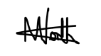
Andy North

Appendix A – Audit Annual Account
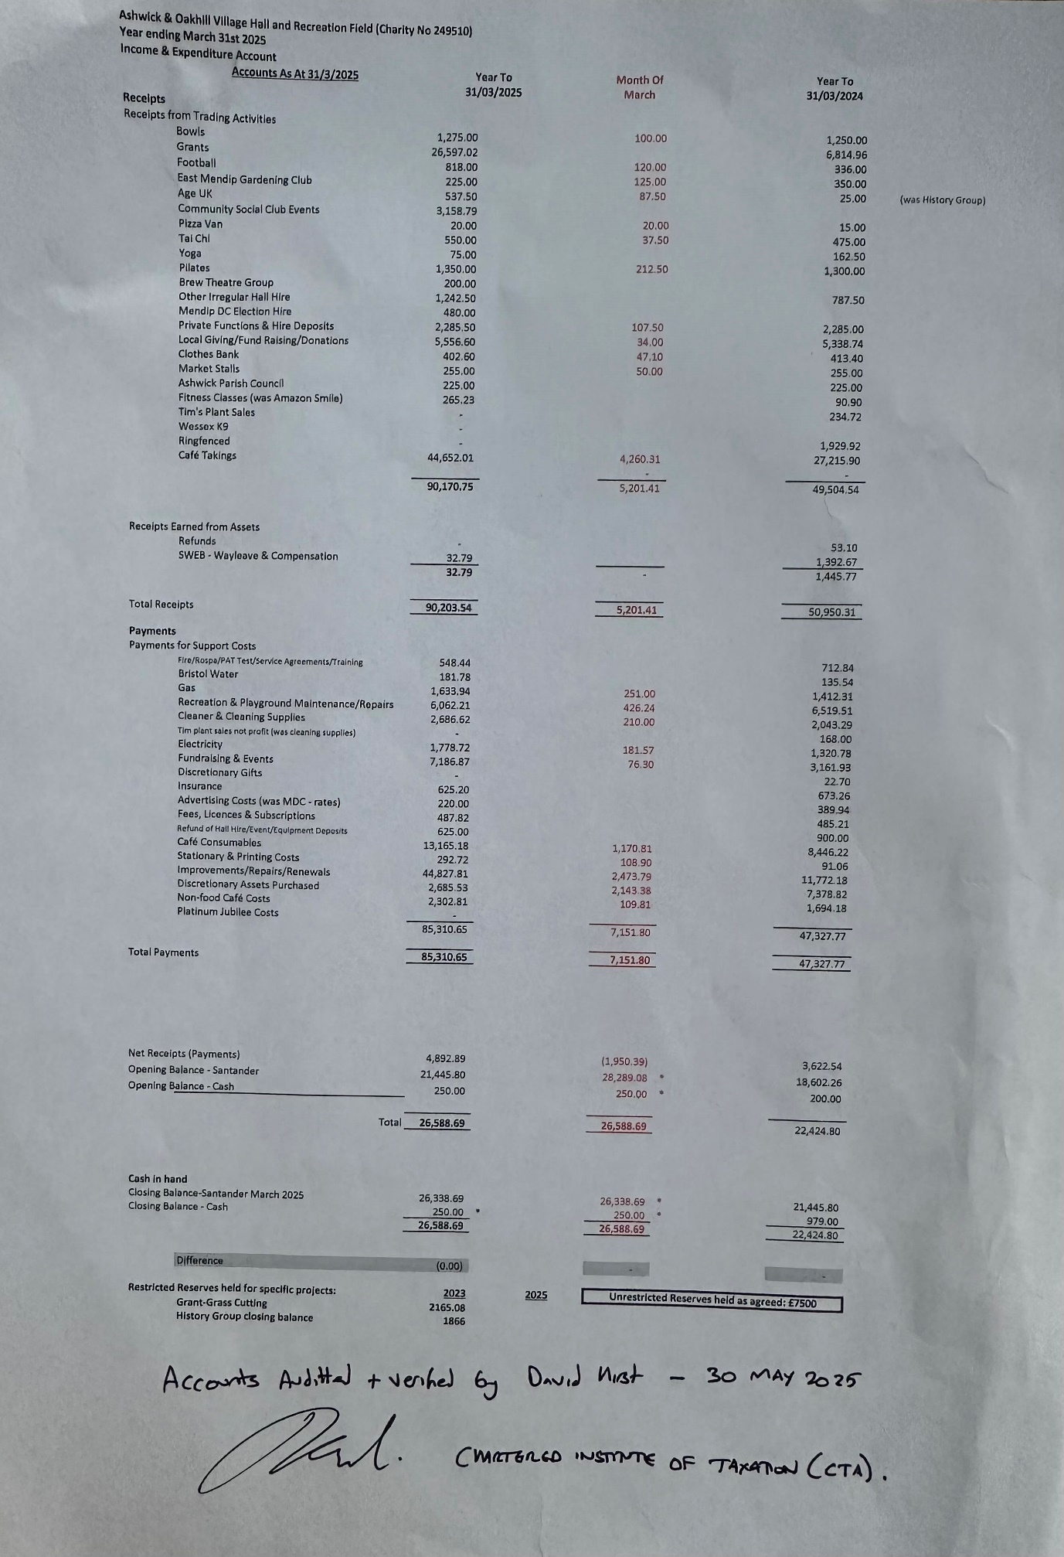

Appendix B – VH Activities – Last 12 months
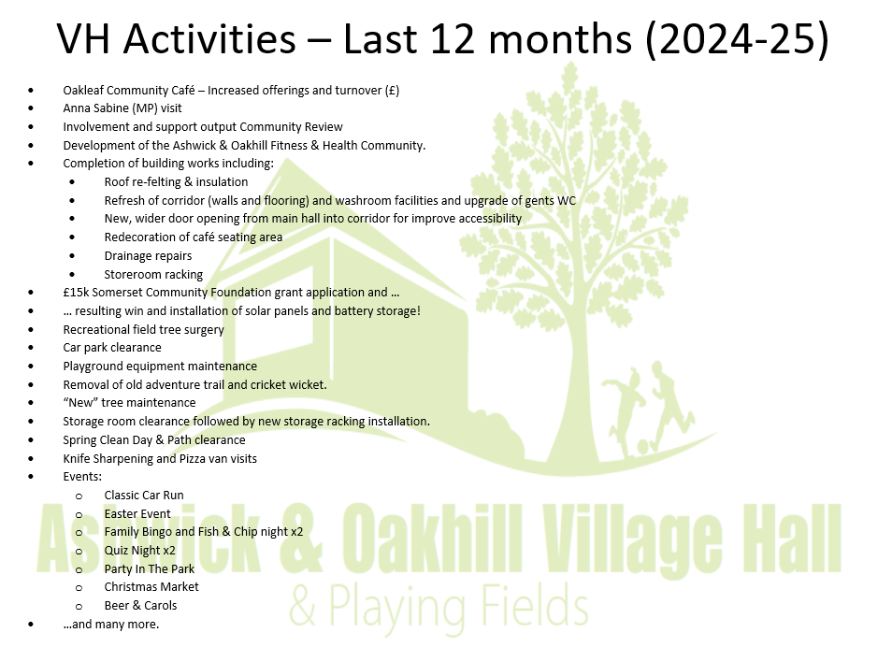

Appendix C – Treasurer’s Summary
